**Wind-Up Carriage Design Challenge**


                            A JOURNEY THROUGH TRANSPORTATION by Chris OxladeIn the book *A Journey Through Transport*, we learn about how people long ago used horses and carriages to move goods and people. Your challenge is to create a modern version of a carriage or sled that can be used with wind-up horsepower (1hp) to transport a load over a distance.

**Challenge:**

Design and build a lightweight carriage or sled that can be pulled behind a wind-up toy horse to transport a given load (e.g., a set weight like 50 grams of marbles, coins, or small blocks) the greatest distance without falling apart, tipping over or stalling.

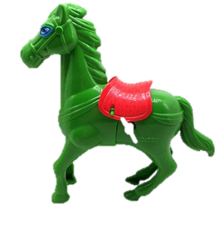**Materials:**

* 1 – sheet of 8.5 X 11 copy paper
* 1 – Small piece of cardboard
* 6” – tape
* 2 - straws
* 1 - Set of wheels and axles

**Tools**: Scissors, rulers, markers,

**Load**:

3D printed haybales, miniature water bottles, marbles, coins, or blocks. Your teacher will designate the required load.

**Wind-Up Horse**: Provided by the teacher. These are somewhat fragile, do not over-wind them please. Additionally, two yard/meter sticks

**Design Constraints:**

1. The carriage/sled must temporarily attach to the wind-up horse using a string or simple hitch (e.g., a loop or knot, tape, etc.).
2. The carriage/sled must carry a given load (multiple haybales, marbles, miniature water bottles, etc.) without tipping over, stalling the horse or losing the load.
3. The total weight of the carriage/sled (without the load) should be as light as possible to avoid slowing down the wind-up horse.
4. The carriage/sled must travel as far as possible on a designated track when pulled by the wind-up horse.

**Extension Challenges:**

* Speed Challenge: Whose carriage/sled goes the fastest?
* Load Challenge: Whose carriage/sled carry a heavier load (e.g., 100 grams)?
* Decoration: Add a historical twist by decorating your carriage like one from the book (e.g., a Victorian carriage or a farmer’s cart).

**Historical Fact:** Before modern trucks and trains, a *Drayman* would deliver heavy loads to rural homes using a heavy wagon pulled by a team of horses. This practice was called *Drayage*.