My Geometric Creature (100 points)

To conclude our on the Geometric Creature Project you will need to create a design in Canva (or a program or app of your choice) with a document size of 8.5” X 11”. Next, use the text tool to copy and paste your creature story onto your design. Using the Elements tool feature draw a likeness of your creature. Additionally, you will include images of your handmade geometric creature and your laser cut creature (made with cardboard). Finally, insert images of your 3D printed geometric creature into the document.
Submit your final work as a .PDF to Blackboard.
Example Student Project –
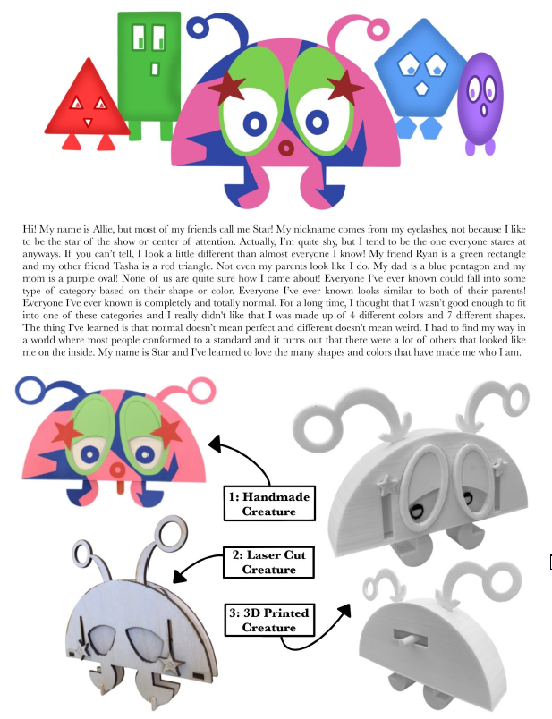
When you have completed your My Geometric Creature document, please submit your final 3D printed design and completed ideation.

