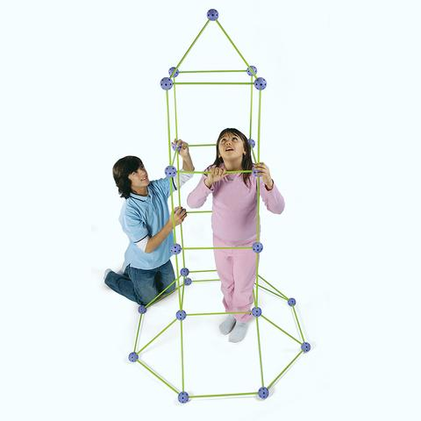



**Big Idea:** Working as a team to build a structure

**Challenge:**

Work with your family or a team and use the Crazy Forts blocks to design and build structure that is large enough so that everyone can fit inside.

**Materials:** Crazy Forts – purple ball fasteners and green sticks

Make sure that the arrows on the purple fasteners are always pointing upward.

* Twist the green sticks to lock them into place in the purple fasteners.
* Please don’t bend the green sticks!





**Big Idea:** Working as a team to build a structure

**Challenge:**

Work with your family or a team and use the Crazy Forts blocks to design and build structure that is large enough so that everyone can fit inside.

**Materials:** Crazy Forts – purple ball fasteners and green sticks

Make sure that the arrows on the purple fasteners are always pointing upward.

* Twist the green sticks to lock them into place in the purple fasteners.
* Please don’t bend the green sticks!

**HexBug Maze Challenge**

**Big Idea:** Problem Solving & Motion

**Challenge:** Your mission is to design an epic escape route for your HexBug! Using Keva blocks, cardboard, and tape, create a maze that will guide your HexBug from start to finish while following your grade-level challenge. Can you outsmart your HexBug and lead it to victory?

**Materials:** HexBugs, Keva Blocks, Cardboard, Tape (1 foot per group)

**Constraints/Limitations:** (Depending on age)

K-1: Get the Hexbug to the other end of the paper using a turn or an incline/decline.

2nd-3rd: Get the Hexbug to the other end of the paper using at least 2 turns or an incline and decline.

4th-5th: Get the Hexbug to the other end of the paper using at least 2 turns and incline and decline.

**Feedback:**

1. What impact does changing the surface affect Hexbug movements?
2. Why did the Keva blocks move when the hexbugs hit them?
3. How did the incline affect the speed of the Hexbug?

**HexBug Maze Challenge**

**Big Idea:** Problem Solving & Motion

**Challenge:** Your mission is to design an epic escape route for your HexBug! Using Keva blocks, cardboard, and tape, create a maze that will guide your HexBug from start to finish while following your grade-level challenge. Can you outsmart your HexBug and lead it to victory?

**Materials:** HexBugs, Keva Blocks, Cardboard, Tape (1 foot per group)

**Constraints/Limitations:** (Depending on age)

K-1: Get the Hexbug to the other end of the paper using a turn or an incline/decline.

2nd-3rd: Get the Hexbug to the other end of the paper using at least 2 turns or an incline and decline.

4th-5th: Get the Hexbug to the other end of the paper using at least 2 turns and incline and decline.

**Feedback:**

1. What impact does changing the surface affect Hexbug movements?
2. Why did the Keva blocks move when the hexbugs hit them?
3. How did the incline affect the speed of the Hexbug?

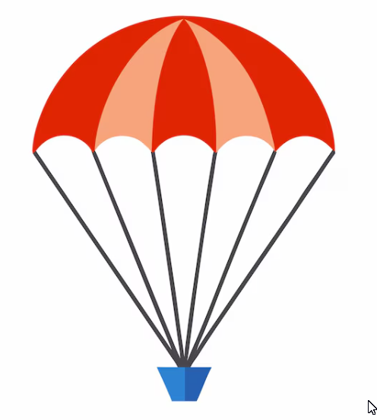**Parachute Design Challenge**

**Big Ideas:** The effects ofgravity – air resistance - drag

**Materials:** Paper plates, paper bags, plastic grocery bag, coffee filter, small cup, string, whiffle ball/ping pong ball

**Tools:** scissors, hole punch

**Challenge:** Design a parachute that can safely drop a ball to the ground.

What forces effect your parachute as is falls to the ground?

What materials worked best for your parachute design?

**Parachute Design Challenge**

**Big Ideas:** The effects ofgravity – air resistance - drag

**Materials:** Paper plates, paper bags, plastic grocery bag, coffee filter, small cup, string, whiffle ball/ping pong ball

**Tools:** scissors, hole punch

**Challenge:** Design a parachute that can safely drop a ball to the ground.

What forces effect your parachute as is falls to the ground?

What materials worked best for your parachute design?

**Spinnovation Station**

**Materials You'll Need:**

* Popsicle Sticks: 5-6
* Pompom: 1
* Ping Pong Ball: 1
* Optional: Markers

Tools: scissors, quick cutters, and *hot glue

**\* Adult Supervision required**

**Big Ideas: Friction and Balance**

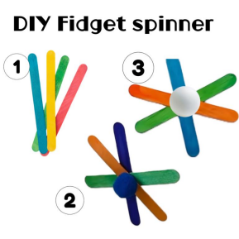

**Instructions:**

**Step 1**: Arrange the Popsicle Sticks. Lay out your popsicle sticks in a star or fan shape.

**Step 2:** Glue the Sticks Together: Lay out your popsicle sticks in a star or fan shape.

**Step 3:** Add the Pompom: Lay out your popsicle sticks in a star or fan shape.

**Step 4**: Attach the Ping Pong Ball: Use hot glue to attach the Ping Pong to the opposite side

**Step 5:** Decorate

**Spinnovation Station**

**Materials You'll Need:**

* Popsicle Sticks: 5-6
* Pompom: 1
* Ping Pong Ball: 1
* Optional: Markers

Tools: scissors, quick cutters, and *hot glue

**\* Adult Supervision required**

**Big Ideas: Friction and Balance**



**Instructions:**

**Step 1**: Arrange the Popsicle Sticks. Lay out your popsicle sticks in a star or fan shape.

**Step 2:** Glue the Sticks Together: Lay out your popsicle sticks in a star or fan shape.

**Step 3:** Add the Pompom: Lay out your popsicle sticks in a star or fan shape.

**Step 4**: Attach the Ping Pong Ball: Use hot glue to attach the Ping Pong to the opposite side

**Step 5:** Decorate