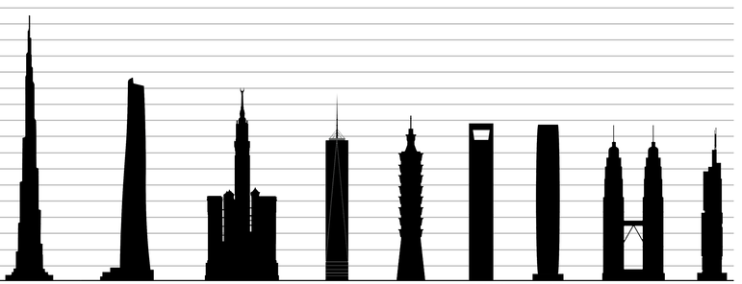
One Way Up
Challenge
Your city needs a new tower to accommodate its rapid growth. However, space is limited and due to overcrowded downtown conditions, a tower needs to be constructed in a small space (represented by a paper plate). Working as a member of an engineering design team, design and construct a tower that can withstand varying wind speeds with a limited footprint for construction while supporting a load (represented by an eraser) at a height of 16”.
Limitations
- Engineering design teams will consist of 2-3 members and your team will be allowed 50 minutes to design, build, and complete final testing.
- Although there is no max-height requirement, the tower must support the load (represented by an eraser) at least 16" above the testing base.
- The tower must be able to be able to be transported to the testing area.
- Although a 9” Paper Plate will be provided as the footprint or base of the tower, you may only use the materials listed below for your design.
- You may test your tower two times; the tower that remains standing in closest proximity to the fan will be determined to be successful.
Materials
- 4 sheets - 8.5” X 11” copy paper
- 1’ masking tape
- 1’ masonry line
- 2 – large paper clips
- 1 – paper plate
- 1 - eraser
Tools
- Scissors
- Ruler
Evaluation
- The judges will place the tower on the testing sled 10’ from the fan. The judges will then gradually move the testing sled (6in-12in) until it is affected by the wind from the fan.
- Each team’s distance between the base of the fan and the front edge of the testing sled will be measured reflect the recorded distance for final testing and ultimately determine the winner.
Please use this area for ideation.
School Name:
_________________________________________________
Team Members:
_______________________________________________

Test 1 -Total Distance from the base of the fan: __________

Test 2 - Total Distance from the base of the fan: __________

