Paper Engineering Project (50pts)
As we discussed with the electricity project, teachers are always looking for a way to tie classroom learning to upcoming events/holidays. Good teachers also look for hands-on activities to promote student engagement and extend learning. Paper-engineering a product such as a pop-up card or book, can also provide a natural hook for students and typically provides the student with something that can be taken home and placed prominently on a shelf or the refrigerator door allowing them to creatively demonstrate what they have learned.
Task:
For this project you conduct research on the best way to design a paper engineering solution and then develop a paper engineering design that could be used to integrate STEM content in your future classroom. You will develop a teaching model inside of a file folder. This type of an assignment is another way that students can demonstrate their understanding of content and can be more engaging than just completing another worksheet.
- Select a big idea (ocean layers, plant/animal life-cycles, etc).
- Conduct research on the topic, identify standards, etc.
- Plan and design your solution.
- Start creating.
Your 3-dimensional pop-up solution must include at least two pop-ups or mechanisms and additional paper sculpting techniques to bring the design to life. Please note that tabs that lift to display text do not count as a pop-up, although you may include these.
On the back of your folder include the grade level, standard (science, technology and engineering, or mathematics), and an appropriate additional standard that could be integrated into this type of project.
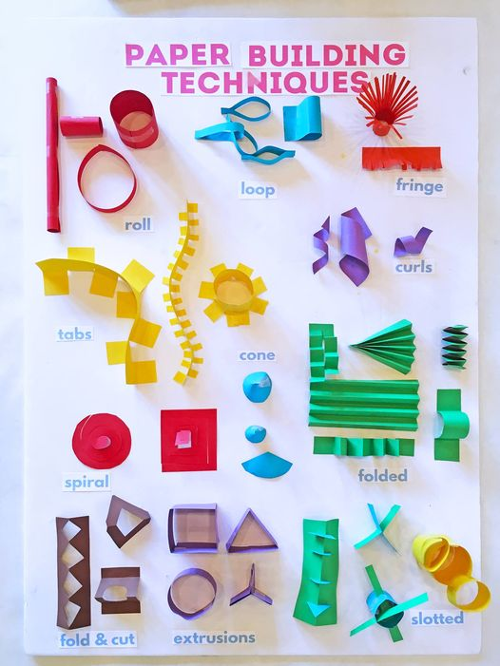
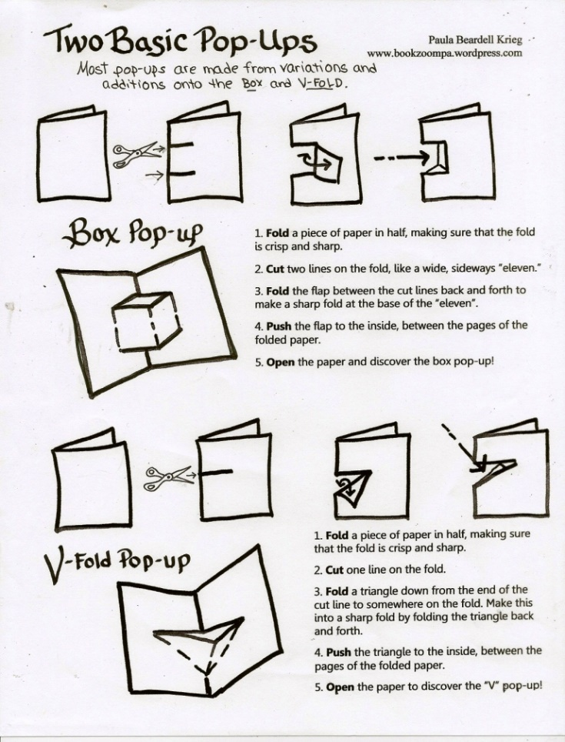

Paper Engineering Project Rubric (50 pts)
Criteria | Exemplary (10 pts) | Proficient (8 pts) | Developing (6 pts) | Needs Improvement (4 pts) | Points Earned
Design Creativity & Innovation | Design is highly creative, innovative, and clearly demonstrates advanced paper engineering techniques. | Design is creative and demonstrates effort, with effective paper engineering techniques. | Design is somewhat creative, but techniques are basic or lack refinement. | Design lacks creativity and effort, with minimal or ineffective techniques.
Mechanisms (Pop-ups & Sculpting) | Includes at least two well-constructed, functional pop-ups or mechanisms and uses paper sculpting techniques effectively. | Includes at least two functional pop-ups or mechanisms, though execution could be improved. | Includes one pop-up or mechanism, or two with significant flaws. | Pop-ups or mechanisms are absent or non-functional.
Integration of STEM Content | Clearly integrates STEM content aligned with grade level and standards, with thoughtful connection to the project. | Integrates STEM content aligned with grade level and standards, though connections may lack depth. | Integration of STEM content is limited or weakly connected to grade level and standards. | Little to no integration of STEM content is evident.
Presentation & Aesthetics | Model is well-crafted, visually appealing, and polished, showing attention to detail. | Model is visually appealing with some attention to detail but may have minor inconsistencies. | Model is functional but lacks attention to visual appeal or neatness. | Model is incomplete, messy, or lacks coherence.
Grade Level & Standards Alignment | Grade level, STEM standard, and additional standard are clearly articulated, appropriate, and effectively integrated. | Grade level, STEM standard, and additional standard are articulated but may lack clarity or complete alignment. | Grade level, STEM standard, or additional standard are unclear or inappropriate. | Grade level, STEM standard, and additional standard are missing or irrelevant.
Comments:
Total Points: ___ / 50

Big Idea

Standards
1.

2.

Content Information

Plan and design your solution

