Saw Building Challenge - Using Simple Tools and Materials in the STEM Laboratory

Background:

Tools for a STEM laboratory can be made from simple materials. Both tools and materials extend human capabilities. The wider the selection of tools and materials available to students, the greater the range of possibilities.

Directions:

Working individually (and following the basic instructions below), build a pull saw and set up your miter box that will be used to cut the materials needed to complete the space frame activity.

Tools Required:

- Hot Glue Gun
- C-Clamp
- Spring Clamp or Binder Clip

Materials:

- Dowel with center hole
- Saw Blade
- Miter Box

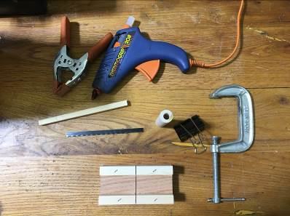

Procedure:

- Heat up your hot glue gun
- Fill the hole in your dowel rod approximately ½ way with hot glue (See Figure 1.)

Figure 1.

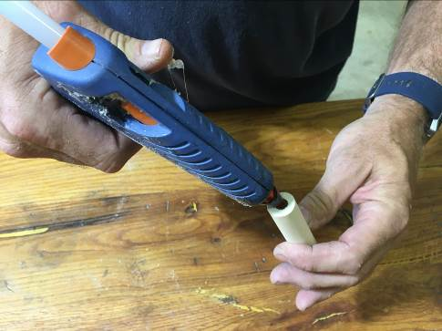

- Identify the tang or shank of the blade (Figure 2.). This is the portion of the blade that will extend into the handle. You will notice that the teeth of the blade have been ground down.

Figure 2.

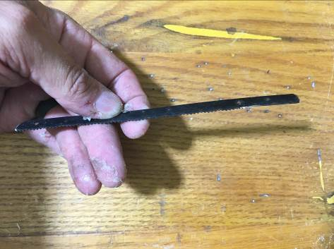

- Fit the tang or shank into the handle and fill to the top with hot glue (See Figures 3. and 4.)

Figure 3. Figure 4.

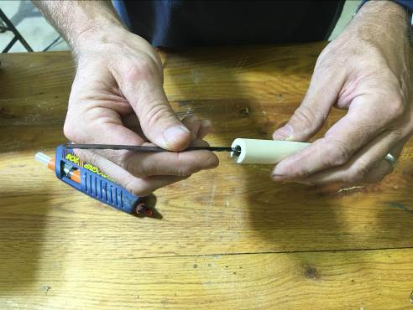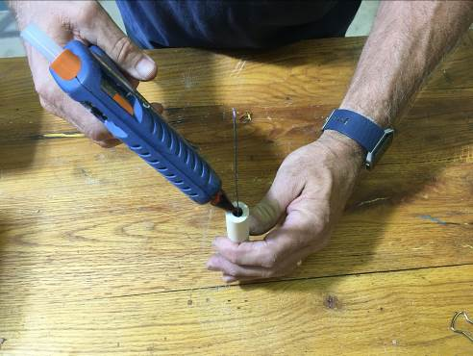

Setting up your miter box to cut–

