Using Simple Tools and Materials in the STEM Laboratory

Background:

Launching an integrated STEM laboratory at the elementary school level does not need to include a huge price tag. Sure, a 3D printer, laser engraver, and multiple robotics kits would be great, but a very effective integrated STEM laboratory could be delivered using simple tools and materials. Both tools and materials extend human capabilities. The wider the selection of tools and materials available to students, the greater the range of possibilities.

Directions:

Working individually (and following the basic instructions below), build a small frame using 3/8” X 3/8” wood that is exactly 6” long and 6” tall (See Figure 1).

Tools Required: Figure 1.
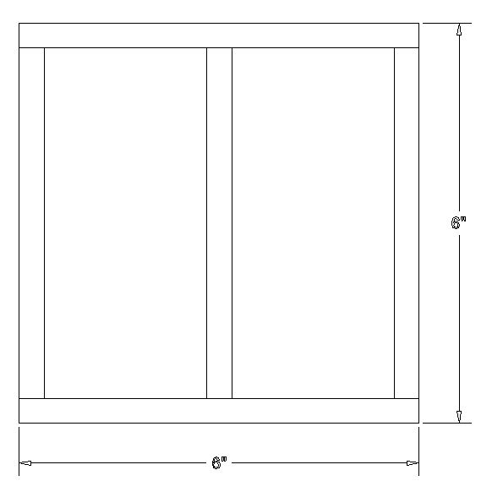
- Miter Box
- Pull Saw or Hack Saw
- Ruler
- Pencil
- Scissors
- Sanding Sponge
- Lynx Jointer (optional)
- Quick Clamp/C-Clamp

Materials:

- 3/8” X 3/8” Pine or Basswood

- Paper (12 - 3/4” X 3/4")
- Glue

Procedure:

To complete this STEM design challenge successfully, you must strictly adhere to the following guidelines:

- You will be allowed 30 minutes to: Design, layout, affix, cut, glue, and assemble your frame.
- You will select materials: 3/8” X 3/8” wood, paper, and glue.
- You will select the tools identified above.
- You will create a sketch that identifies the length and position of each of the 5 pieces of your frame (the center upright will be located in the exact center of your frame). Hint: You have been given the overall length and height of the frame, but you will need to calculate the length of the 3 upright pieces.
- You will then use the miter box and pull saw/hack saw to cut the base and top material to 6” lengths. The miter box should be clamped using a quick or c-clamp.
- You will use the miter box and pull saw/hack saw to cut the appropriate length of 3 pieces of upright material.
- Double-check each of your pieces to ensure the correct dimensions. You will then use the sanding sponge to sand the cut materials - making certain that all sharp and rough edges are removed.
- You will then cut 12 gussets (3/4” X 3/4" paper) that will be used to affix and strengthen the joined materials. A gusset or gusset plate is used in construction to connect bracing members to other structural members.in the structure (See Figures 2, 3, & 4 below).
Figure 2.
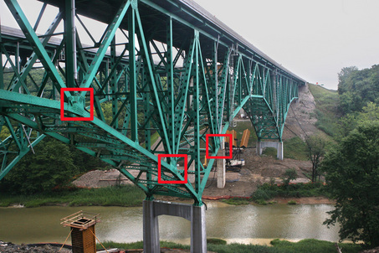

Figure 3. Figure 4.
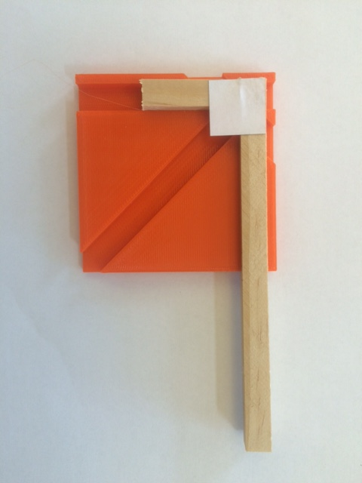

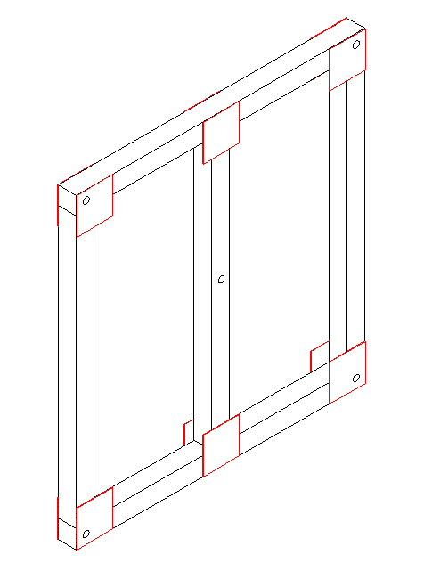

- You will assemble the frame using glue and the gussets (see Figures 3 & 4). Be sure that your frame is square (*check diagonals).

- Be sure to write your name on your frame. You will need to allow your frame to dry overnight. Testing and drilling of 3/16” holes will be done during the following class meeting.

